Exam PA October 11, 2022 Project Statement

This model solution is provided so that candidates may better prepare for future sittings of Exam PA. It includes both a sample solution, in plain text, and commentary from those grading the exam, in italics. In many cases there is a range of fully satisfactory approaches. This solution presents one such approach, with commentary on some alternatives, but there are valid alternatives not discussed here.
General Information for Candidates
This examination has 12 tasks numbered 1 through 12 with a total of 100 points. The points for each task are indicated at the beginning of the task, and the points for subtasks are shown with each subtask.
Each task pertains to the business problem (and related data files) and data dictionary described below. Additional information on the business problem may be included in specific tasks—where additional information is provided, including variations in the target variable, it applies only to that task and not to other tasks. An .Rmd file accompanies this exam and provides useful R code for importing the data and, for some tasks, additional analysis and modeling. There are five datasets used in this exam. They are all subsets of a larger dataset that is not given to candidates. The .Rmd file has a chunk for each task. Each chunk starts by reading in one or more data files into one or more dataframes that will be used in the task. This ensures a common starting point for candidates for each task and allows them to be answered in any order. When the datafile is read, the variables it contains are assigned a type (e.g., “numerical,” ”factor”). The code that assigns variable types is easily changed (e.g., if month is read in as “numeric” but you want to treat it as a factor).
The responses to each specific subtask should be written after the subtask and the answer label, which is typically ANSWER, in this Word document. Each subtask will be graded individually, so be sure any work that addresses a given subtask is done in the space provided for that subtask. Some subtasks have multiple labels for answers where multiple items are asked for—each answer label should have an answer after it. Where code, tables, or graphs from your own work in R is required, it should be copied and pasted into this Word document.
Each task will be graded on the quality of your thought process (as documented in your submission), conclusions, and quality of the presentation. The answer should be confined to the question as set. No response to any task needs to be written as a formal report. Unless a subtask specifies otherwise, the audience for the responses is the examination grading team and technical language can be used. When “for a general audience” is specified, write for an audience not familiar with analytics acronyms (e.g., RMSE, GLM, etc.) or analytics concepts (e.g., log link, binarization).
Prior to uploading your Word file, it should be saved and renamed with your five-digit candidate number in the file name. If any part of your exam was answered in French, also include “French” in the file name. Please keep the exam date as part of the file name.
It is not required to upload your .Rmd file or other files used in determining your responses, as needed items from work in R will be copied over to the Word file as specified in the subtasks.
The Word file that contains your answers must be uploaded before the five-minute upload period time expires.

Business Problem
Your boss recently started a consulting firm, PA Consultants, specializing in predictive analytics. You and your assistant are the only other employees. Your boss informs you that a local politician from Baton Rouge, Louisiana, USA has hired your firm.
Baton Rouge, a city of about 230,000 residents, is the capital of the state of Louisiana, USA.
The client is about to launch a campaign with the mottos, “Clean up Baton Rouge” and “Treat all Neighborhoods Equally – including yours!” The client wants to improve garbage and waste collection. In particular, the client cares about shortening resolution times and ensuring equitable resolution times throughout the city.
The client wants your ideas and inputs on the following:
- Understanding time trends

- Seeing whether different responding departments have different resolution times for similar tasks

- Predicting resolution times for any type(s) of complaint
Your boss directs you to use a dataset of public data that includes all the service requests from January 2016 – March 2022. There are over 300,000 service requests in this time period. Your assistant has prepared five subsets of the public data and has provided the following data dictionary that contains all the variables appearing in the subsets. Note that all variables do not appear in every subset datafile.

Data Dictionary

Variable Name | Variable Values
Time.to.resolution | Days from service request to resolution
quarter | “Q1”, “Q2”, “Q3”, “Q4”; quarter of service request
month | 1 to 12, month of service request
year | 2016 to 2022, year of service request
year.mo | 201601 to 202203, 100*year + month
DEPARTMENT | “GROUNDS”,”BLIGHT”,”SANITATION”
LATITUDE | Latitude of service location, 30.2 to 30.6
LONGITUDE | Longitude of service location, -91.3 to -90.9
area | “N”,”W”,”D”,”LSU”; neighborhood of service location
Latitude_Binned | Latitude range for binned data (geo.grid.csv only)
Longitude_Binned | Longitude range for binned data (geo.grid.csv only)
Ave.time.to.resolution | Average Time.to.resolution for binned data (geo.grid.csv only)
call.count | Number of service requests for binned data (geo.grid.csv only)
TYPEid | An id representing a specific type of service request

Comments
Requests for service do not appear in the dataset until they are resolved.

Task 1 (7 points)
Your boss asks you to review the quality of the data below. The data shows Time to Resolution for calls to pick up unwanted garbage carts. (This data is not found in any of the supplied files.)
- (2 points) Review the box plot below that your assistant made and describe an issue with the data.
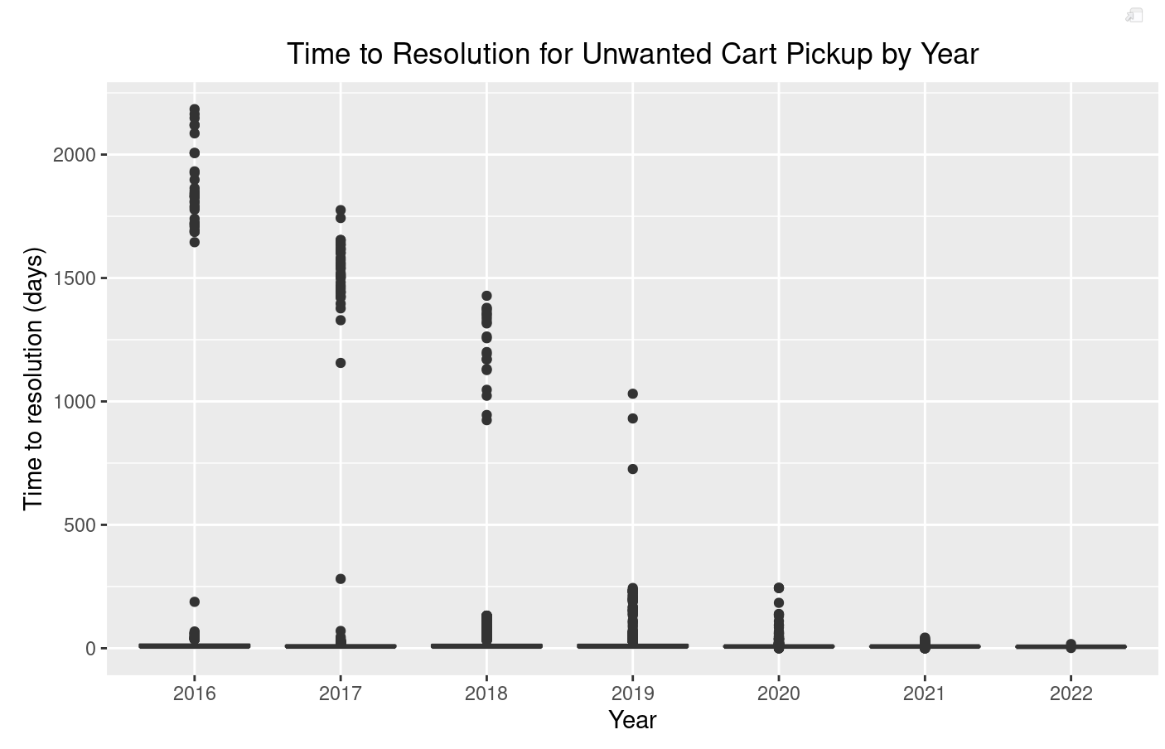
Candidates received full credit for identifying outliers with very high time to resolution as an issue and describing how the outliers may arise, patterns in the outliers, or how the outliers could cause problems in addressing the business problem. A common mistake was misidentifying the outliers as the body of the distribution and stating the actual boxplot represents unreasonable zero values, when in fact, this is an artifact of the scale of the y-axis caused by the high outliers.

ANSWER:
The plot shows many outlier resolution times greater than one year. These resolution times are unreasonable for trash services. This suggests either that services were never performed or that the cases were not closed at the time service was completed.

- (1 point) List three options for handling the data issue.

Candidates received full credit for listing three distinct options that addressed the data issue. The most common mistakes were listing options to improve the graph rather than handle the data issue (e.g., using a log scale) and giving vague response (e.g. listing “further investigation” as an option).

ANSWER:
1. Remove outliers with very high time to resolution from the dataset
2. Leave the outliers in the dataset without any modification
3. Censor the time to resolution variable

- (2 points) Select and explain which option from part (b) you would recommend.

Candidates performed well on this task overall. The most common recommendation was removing the outliers, but full credit was granted for any recommendation with a reasonable explanation.

ANSWER:
I recommend removing the data with excessive resolution times. It seems likely that the requests were not closed when the service was performed because these response times stretch over multiple years.

- (2 points) Your assistant produces the following output from a GLM. (Note your assistant redefined year as years since 2016.)

This is a relatively straightforward calculation task, and candidates performed well overall. Varying amounts of partial credit were awarded to candidates with incorrect answers. Calculation errors (e.g., missing a coefficient in the formula) were awarded more partial credit than incorrect formulas (e.g., ignoring or misapplying the link function, incorrect residual calculation).

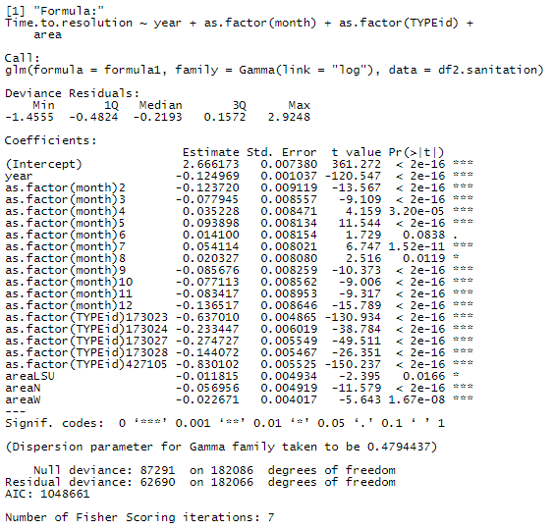

Calculate the residual for the predicted time to resolution using the values in the following table for a single observation. Show both the formula(s) used (with values substituted for variables) and the final value to two decimal places.

TYPEid | month | year | Area | Time to Resolution
173023 | 2 | 4 | N | 5

ANSWER:

Task 2 (11 points)
The client is interested in improving the debris collection performance.
Candidates performed well on this task overall. For full credit, both a correct, legible table, and the R code used to generate the table were required.
- (2 points) Create a table showing number of observations by year and month. Paste the R code and the table below.
ANSWER:
R Code:

table(df.debris$year, df.debris$month)

Table:

1 2 3 4 5 6 7 8 9 10 11 12
2016 239 330 457 483 633 883 603 372 707 910 706 521
2017 716 665 1012 912 907 763 854 851 968 832 672 427
2018 385 613 2030 1806 1527 1455 1436 1275 1025 1042 595 606
2019 729 754 1113 1547 1737 1857 1836 1609 1172 722 542 602
2020 566 484 895 881 1366 1367 1601 1125 1024 763 554 695
2021 361 225 918 607 1112 2321 1248 1889 960 1032 693 640
2022 404 241 100 0 0 0 0 0 0 0 0 0

- (2 points) Recommend which time period you will choose to use for your analysis (in terms of years and months). Justify your recommendation.
Candidates performed well on this task overall. For full credit, candidates needed to address incomplete 2022 data and provide a justification grounded in the business problem.
ANSWER:
I recommend using all months of data from years 2018-2021. Starting with 2018 gives four years of data, which is enough to see recent trends. I recommend not using 2022 data since there is not data for all months, and we are only excluding 745 observations by removing 2022 data.

Your boss told your assistant to use stratified sampling when separating the chosen dataset into a training dataset and a testing dataset.
- (2 points) Discuss the benefits of stratified sampling.
Candidate performance was mixed on this task. Partial credit was awarded for a definition of stratified sampling, but a clear discussion of the benefits was required for full credit.
ANSWER:
Stratified sampling results in test and train datasets that are similar with respect to the stratification variables. To the extent that the stratification variables are related to the target variable, stratification will allow for more precise train and test estimates. Not stratifying on important predictor variables would add variance to the model because it would be fit to the segmentation of the training data, which is similar to overfitting to noise in the dataset. The test dataset would have a different segmentation, and therefore the model may not fit the test data as well as the train data.

Your assistant has stratified the entire dataset, based on month and year, and divided it into train and test datasets. You need to remove any observations that you decided not to use in (b).
- (2 points) Remove the observations that you decided in (b) not to use from the train and test datasets. Copy the code to adjust datasets.

This is a straightforward question on R coding. The majority of candidates received full credit.
ANSWER:
Code to adjust datasets:
debris_train <-debris_train[debris_train$year < 2022,]
debris_train <-debris_train[debris_train$year > 2017,]
debris_test <-debris_test[debris_test$year < 2022,]
debris_test <-debris_test[debris_test$year > 2017,]

Your assistant has prepared glm1 and glm2. Run the .Rmd file to fit the models.
- (3 points) State the better of the two models, based on RMSE. Copy the code (i.e., the glm command, and any further lines of code) for both of the models that you used to make the choice.

Candidate performance was mixed on this task. Many candidates received some amount of partial credit due to coding errors, incorrectly stated that higher RMSE indicates better model performance, or identifying a better model based on criteria other than RMSE.
ANSWER:
Model choice (erase one): Poisson GLM
RMSE for Gamma GLM: 60.2934
RMSE for Poisson GLM: 55.3739
Code to calculate Gamma GLM RMSE:
glm1.time <- predict(model.glm1, newdata=debris_test, type = "response")
RMSE.1 <- sqrt(mean((debris_test$Time.to.resolution - glm1.time)^2))
Code to calculate Poisson GLM RMSE:
glm2.time <- predict(model.glm2, newdata=debris_test, type = "response")
RMSE.2 <- sqrt(mean((debris_test$Time.to.resolution - glm2.time)^2))

Task 3 (9 points)
Your boss is interested in providing an update to the client about interesting findings coming out of the exploratory data analysis. Specifically, your boss would like to present on how resolution times vary by year and if there are any differences by department:
- (3 points) Create a graph to show how resolution times vary by year, split out by department type. Paste the graph and paste code for the graph below. (Refer to the code provided in the RMD file.)
Candidates performed very well on this task, with most candidates receiving full credit. The most common approaches receiving full credit were box plots with the department dimension reflected using facet wrap or facet grid (as in the model solution) or the fill (color) aesthetic. Partial credit was awarded for graphs that showed only the average resolution time rather than a distribution. Partial credit was also awarded for graphs that showed the full distribution in a way that was difficult to compare across year and department (e.g., creating 18 different histograms).
ANSWER:
Graph:
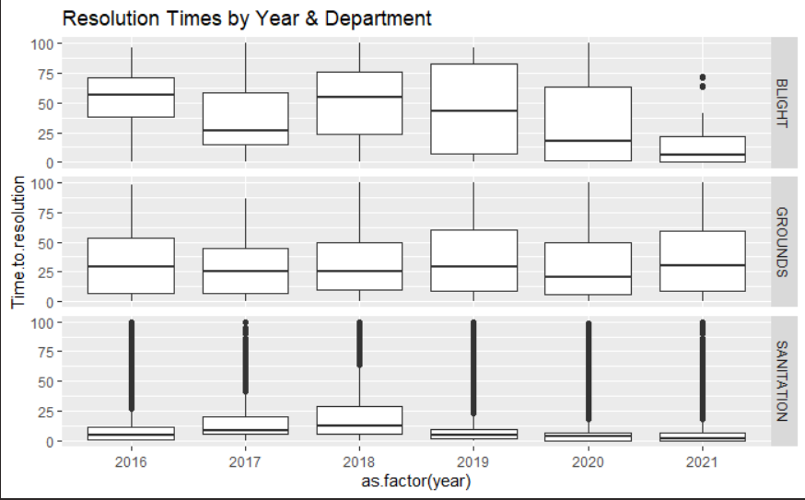
Code:
p1 <- ggplot(data = df.task1, aes(x = as.factor(year), y = Time.to.resolution)) + geom_boxplot()
p1 + facet_grid(rows = vars(df.task1$DEPARTMENT)) + labs(title="Resolution Times by Year & Department")

- (2 points) Describe any trends seen in the graph.
Candidate performance was mixed on this task. For full credit, candidates were expected to comment on a trend across departments and also a trend across years or an observed interaction between the two variables. Trends based on the median or the distribution/skewness were accepted.
ANSWER:
Median resolution times are consistently lower across all years for the Sanitation department compared to the other two departments.
The Grounds department shows less variation in resolution times over the years, whereas the Sanitation and Blight departments seem to have a decreasing trend in median resolution times from 2018 onwards.

You have asked your assistant to use stepwise selection as a possible method to select predictors in a final model.
- (2 points) Contrast best subset and stepwise selection for selecting predictors.
Candidates mostly performed well on this task. Full credit responses provided a description of both methods, mentioning the two key differences: (1) Best subset will find the optimal set of predictors, i.e., the global minimum, whereas stepwise selection will find a local minimum which may have a higher error than the global minimum; (2) Best subset will require more computational time, especially when many variables are being considered. Partial credit was awarded for only discussing one of the key differences, or discussing other, less relevant differences like best subset being potentially more susceptible to overfitting.
A common mistake was candidates contrasting forward and backward selection rather than contrasting best subset and stepwise selection as the task required. No credit was awarded for these responses.
ANSWER:
Best subset selection is performed by fitting all p models, where p is the total number of predictors being considered, that contain exactly one predictor and picking the model with smallest deviance, fitting all p choose 2 models that contain exactly 2 predictors and picking the model with lowest deviance, and so forth. Then a single best model is selected from the models picked, using a metric such as AIC. In general, there are 2^{p} models that are fit, which can be quite a large search space as p increases.

Stepwise selection is an alternative to best subset selection, which is computationally more efficient, since it considers a much smaller set of models. For example, forward stepwise selection begins with a model containing no predictors, and then adds predictors to the model, one-at-a-time, until adding a predictor leads to a worse model by a measure such as AIC. At each step the predictor that gives the greatest additional improvement to the fit is added to the model. The best model is the one fit just before adding a variable leads to a decrease in performance. It is not guaranteed that stepwise selection will find the best possible model out of all 2^{p} models.

Your assistant believes that stepwise selection could lead to a suboptimal model being fit and that best subset selection should always be performed.
- (2 points) Critique the assistant’s assertion that best subset selection should always be used since stepwise selection could lead to a suboptimal choice for the model.
Candidates performed well on this task. Most candidates correctly noted that the computational burden of best subset is onerous in many circumstances, and that stepwise selection may be a satisfactory alternative in these situations.
ANSWER:
The assistant is right in saying that stepwise selection could yield a suboptimal model in comparison with best subset selection since it is performed on a restricted search space of models. However, computationally, best subset selection can lead to a very large search space. This is why stepwise selection can often be used as a more efficient alternative, especially when working with a large number of predictors, which may often be the case with large datasets where a variety of predictors are being tested.

Task 4 (7 points)
Your boss wants you to build a tree model to better understand the Time.to.resolution for discarded couches and mattresses. (The data used is not found in any of the supplied files.)
- (2 points) Describe two ways impurity measures are used in a classification tree.
Candidates performed well on this task. Full credit responses clearly explained two or more ways that impurity measures are used in building, pruning, or evaluating classification trees.
ANSWER:
One way that impurity measures are used in a classification tree is to decide which split in the decision tree (if any) should be made next. A second way impurity measures can also be used is to decide which branches of the tree to prune back after building a decision tree by removing branches that don’t achieve a defined threshold of impurity reduction through cost-complexity pruning.

Your assistant has built a tree model and noticed that for all values of the cp parameter the model never splits on DEPARTMENT but always includes splits on TYPEid.

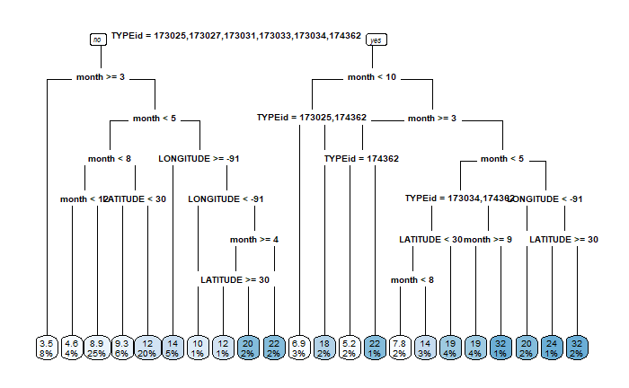
Your assistant also generated a summary table by DEPARTMENT and TYPEid for you to review.
DEPARTMENT | TYPEid | n() | mean(Time.to.resolution)
BLIGHT | 173034 | 19 | 22.421053
GROUNDS | 173021 | 3 | 5
GROUNDS | 174362 | 337 | 20.175074
SANITATION | 173020 | 1 | 3
SANITATION | 173023 | 13 | 8.615385
SANITATION | 173024 | 3012 | 10.134462
SANITATION | 173025 | 1 | 18
SANITATION | 173026 | 23 | 8.347826
SANITATION | 173027 | 686 | 15.262391
SANITATION | 173029 | 1 | 5
SANITATION | 173031 | 1 | 19
SANITATION | 173032 | 9 | 5.333333
SANITATION | 173033 | 17 | 16.647059

- (2 points) Explain why the classification tree does not split on DEPARTMENT.
Candidates performed well on this task. Most full credit answers fell into one of two categories: (1) Responses correctly identifying that DEPARTMENT adds no marginal predictive power to TYPEid as in the model solution; (2) Responses that identified that TYPEid has more levels than DEPARTMENT and provided a strong explanation for why decision trees prefer to split on variables with more levels.
ANSWER:
The DEPARTMENT variable is perfectly predicted by the TYPEid variable since each TYPEid maps to only one DEPARTMENT. This means that the DEPARTMENT variable adds no additional information to the model beyond what is included in the TYPEid variable, and thus the tree does not need to split on it.

Based on the preliminary findings, your boss suggests you round the values of LONGITUDE and LATITUDE variables to 1 decimal place.
- (3 points) Explain potential issues with the LONGITUDE and LATITUDE variable before they were rounded and how your boss’s suggestion would address these concerns.
Candidate performance was mixed on this task, with the majority of candidates receiving some amount of partial credit. Full credit responses discussed how a tree built on the unrounded variables would be susceptible to overfitting and explained how the boss’s suggestion effectively transforms both variables into factor variables with few levels. Although the modeling considerations were considered most relevant, responses discussing privacy concerns (with no mention of modeling implications) were awarded partial credit.
ANSWER:
Tree models favor variables that have many ways to split, including continuous numerical variables and categorical variables with many levels. In the dataset, both LONGITUDE and LATITUDE are numerical with 5 decimal places. The original tree model sequentially splits on both LONGITUDE and LATITUDE, and that could easily create bias and result in local overfitting.
The suggestion to round LONGITUDE and LATITUDE to 1 decimal reduces the opportunity for overfitting (there are only 4 possible combinations of LATITUDE and LONGITUDE after the adjustment). It also ensures that model splits reflect meaningful differences in location.

Task 5 (5 points)
Your assistant fit a GLM to predict the resolution time for garbage cart requests from new residents. (The data used is not in any of the supplied files.) The assistant chose to fit two different distributions, a Poisson and a quasi-Poisson distribution. Refer to output below:

- (3 points) Assess the two chosen distributions with respect to reasonability in modeling Time.to.resolution as a target variable, using the output provided by the assistant.
Few candidates received full credit on this task. Full credit responses identified overdispersion from the model output and explained its implications in interpreting and using model output from models using the respective distributions. Partial credit was awarded for responses that identified numerical differences between the output of the two models but did not connect the differences to properties of the two distributions. Minimal partial credit was awarded to candidates who remarked only on the applicability of the Poisson distribution without contrasting it with the quasi-Poisson.
ANSWER:
An underlying assumption of Poisson regression is that the mean and variance are equal. The assistant’s code shows that the variance is greater than the mean for new resident requests, indicating evidence of overdispersion.
Quasi-Poisson regression is equipped to deal with the problem of overdispersion. Notably, the estimates of the coefficients are the same when compared to the Poisson output. However, the standard errors are all higher and fewer coefficients are statistically significant (coefficients for months 2, 4, 7, 12, and LONGITUDE are not significant in the quasi-Poisson output, whereas only month 7 is not significant in the Poisson output).
While both distributions could be used for modeling as they ultimately lead to the same predictions, if any further analysis is conducted such as deriving confidence intervals or conducting hypothesis tests, the quasi-Poisson distribution should be used.

Your boss would like you to consider other distributions for the GLM.
- (2 points) Recommend two additional distributions along with link functions that are reasonable choices to model Time.to.resolution. Justify your recommendations.
Candidates performed well on this task overall. Full credit responses recommended distributions and link functions with justification based on the characteristics of the target variable such as the domain and skewness of the data. A common reason for candidates receiving only partial credit was justifying only the distribution or the link function.
ANSWER:
I recommend fitting the following, with the target variable being Time.to.resolution + 1:
- Gamma distribution with a log link function
- Inverse gaussian with a log link function
Adding 1 (or another small positive value) to Time.to.resolution is necessary since the log link does not support 0 values, which do exist in the Time.to.resolution variable. Using the log link function ensures that the predictions are positive.

The two recommended distributions support continuous values while the target variable contains only integer values. However, these distributions are still practical choices given the target variable is positive and right-skewed.

Task 6 (10 points)
The client is interested in improving furniture disposal pickup times. Your assistant prepares a GLM and a decision tree that model Time.to.resolution using LATITUDE and LONGITUDE as predictor variables. (The data used is not in any of the supplied files.)
- (2 points) Contrast using a GLM versus a decision tree given the client’s goals and the variables chosen to use in these models.
Note: There was overlap in rationale candidates provided in tasks 6(a) and 6(b). Credit was awarded for reasonable justifications whether they were provided as a response to 6(a) or 6(b). This commentary applies to both 6(a) and 6(b).
Performance was mixed on these tasks. Full credit responses described how each model would interpret the geospatial data and contrasted those observations in the context of the client’s goal to treat neighborhoods equally. Most full credit responses identified a weakness in using a GLM based on the raw geospatial variables and how a decision tree can overcome the weakness. Credit was awarded for discussing either why the linear relationship assumption or the inability of a GLM to identify interactions is unreasonable. Partial credit was awarded to responses that addressed these weaknesses in vague terms, e.g., stating that decision trees have more flexibility to fit to a variable.
ANSWER:
A GLM trained on LATITUDE and LONGITUDE as predictor variables will produce coefficients representing how the target variable (time.to.resolution) varies linearly from west to east and from south to north across the city. If time.to.resolution does vary geographically, it seems more likely that there will be certain sections of the city (e.g., neighborhoods, districts) where the time.to.resolution may be higher or lower than the city-wide average, as compared to a linear function of the time.to.resolution across the city.
A decision tree will be more adept at identifying sections of the city with higher or lower times to resolution compared to the city wide average by determining several splits in which the city may be divided into any number of rectangular sections. Also, decision trees do not assume that the target variable has linear dependence on the predictor variables.

- (2 points) Recommend either the GLM or decision tree to use and justify your recommendation.
See note for 6(a).
ANSWER:
A decision tree will produce splits that would allow the client to divide the city into areas with longer and shorter times to resolution. The decision tree also does not assume linear dependence on the predictor variables like the GLM does and there is no reason to expect that a linear relationship should exist. For these reasons, I recommend using the decision tree for this problem.

Your assistant produced a decision tree to predict Time.to.resolution using LATITUDE and LONGITUDE. Your assistant provides you with the following code and output below:
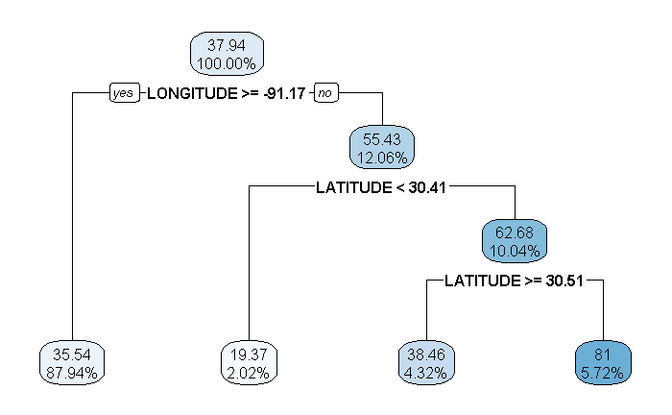
- (3 points) Interpret a few select components of this plot by filling out the table below:
Candidates performed well on this task overall. Most candidates were able to interpret the decision tree with either no errors or only minor errors.
ANSWER:
Component of Plot | Interpretation
55.43 | The average time.to.resolution for all records in the training data where the LONGITUDE is not greater than or equal to -91.17
12.06% | The percent of all records in the training data where the LONGITUDE is not greater than or equal to -91.17.
Latitude < 30.41 | This is the split that produces the highest reduction of node impurity for all records of the training data that have a LONGITUDE not greater than or equal to -91.17. In other words, within all training data records with longitude less than -91.17, further splitting the data using LATITUDE less than 30.41 as a splitting criteria produces the greatest difference in average time.to.resolution of the resulting leaves, while also requiring that hyper parameter pruning measures are met (e.g. minimum number of records in leaves). Records with LATITUDE less than 30.41 are grouped in the left leaf from this node, and records with LATITUDE greater than or equal to 30.41 are grouped in the right leaf from this node.
38.46 | This is the average time.to.resolution for all records that end up in this leaf. Records in this leaf are those with LONGITUDE less than -91.17, and LATITUDE greater than or equal to 30.51.
5.72% | This the percent of all records that end up in this leaf. Records in this leaf are those with LONGITUDE less than -91.17, and LATITUDE between 30.41 and 30.51

Your assistant wants to recommend that the client includes shortening furniture disposal service request resolution times as part of their campaign.
- (3 points) Critique your assistant’s recommendation and consider model efficacy and potential equity concerns.
Candidates struggled with this task. Full credit responses addressed both equity and efficacy. The most common model efficacy concern that received full credit was that the model is only built on geospatial variables, and other variables should be considered to add predictive power. Similarly, the most common equity concern was that geospatial variables could be a proxy for protected classes.
ANSWER:
Based on the plot of the decision tree in subtask b, the time.to.resolution for service requests relating to furniture varies significantly by geography. The assistant’s recommendation to the client seems reasonable based on the results of the decision tree. However, there are several considerations that should be discussed with the client before they move forward with using this recommendation. A few of these considerations are listed as follows:
- Allocating resources geographically could have negative downstream effects if not done carefully. Race, ethnicity, socio-economic status, age, and other demographics often vary geographically. Focusing garbage collection resources in some districts over others could indirectly produce differences in resource access for one of these demographic categories listed, which could have negative political or social impacts on the client.
- The decision tree supporting this decision is fairly simple and does not contain details regarding the distribution of time until resolution by node. For example, if a couple of outliers are contributing towards the node with the long time until resolution, this could skew the interpretation of this plot and potentially provide the client with a false focus.
- This decision tree only focuses on LATITUDE and LONGITUDE to predict the time until resolution. There may be other strong predictors as well. It might be wise to have a more complete picture of the predictors before reaching out to the client with recommendations.

Task 7 (9 points)
As part of the exploratory data analysis process, your assistant decides to focus on service requests involving mattresses, couches, and sofas. To reduce the number of observations, your assistant also restricts the dataset to include only observations from prior to 2020. (The data used is not in any of the supplied files.)

Using the dataset described above, your assistant decides to use K-means clustering using LATITUDE and LONGITUDE variables and produces the plot shown below.
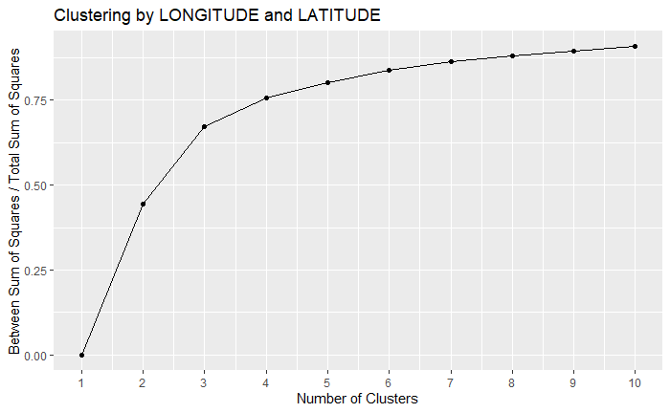

- (2 points) Identify the type of plot and explain what it depicts.
This was a straightforward task, and candidates performed well overall. Full credit was awarded for identifying the plot as an elbow plot and a description.
ANSWER:
This is an elbow plot which depicts the percentage of variance explained each time a new cluster is added. The Y axis depicts the F-statistic which is group variance divided by the total variance.

- (2 points) Recommend the number of clusters to use and justify your recommendation.
This task was also straightforward, with candidates performing well overall. Partial credit was awarded for choices of K other than 3, depending on the strength of the justification.
ANSWER:
The optimal value of K is 3, where the marginal increase in the ratio of between-cluster and total-sum of squares levels off. When the marginal increase in this ratio is large, adding another cluster puts observations with materially different characteristics into different clusters.
On the other hand, when the marginal increase in the ratio is small, adding another cluster could result in two or more clusters of observations with similar characteristics.

Your assistant is using K-means clustering to create a feature to be used as a predictor variable in a GLM where the target variable is time to resolution. Your assistant wants to use the following three variables as inputs into the K-means clustering algorithm: LATITUDE, LONGITUDE, and Time.to.resolution.
- (2 points) Critique the recommendation described above.
Candidate performance was mixed on this task. Full credit responses identified the target leakage concern, with or without directly using the technical term “target leakage,” and described why this is an issue. Many candidates provided general critiques of K-means without identifying the significant target leakage issue. These candidates were awarded minimal partial credit.
ANSWER:
Clustering is an unsupervised learning method where a target variable is not specified. Clustering can be useful in exploratory data analysis in exploring relationships between the target and dependent variables. However, predicting Time.to.resolution using clusters based on Time.to.resolution introduces target leakage, where the model would need to know the target variable to “predict” the target variable, which is inappropriate.

Using the variables LATITUDE, LONGITUDE, and Time.to.resolution, your assistant performs K-means clustering with K=2. Your assistant performs the analysis with and without variable scaling but forgets to label the output properly. When clustering is done on scaled variables, the plot is made using the unscaled values. Note that the plots below depict only two of the three variables.
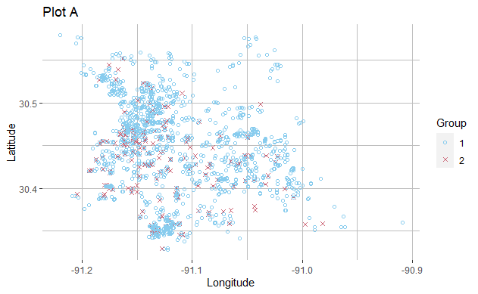
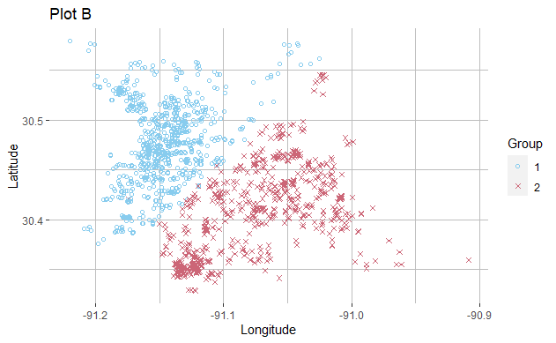

- (3 points) Identify which plot reflects the version where the variables were scaled and discuss how scaling created such large differences in how the data appear in these plots.
Candidates performed relatively well on this task overall. Some candidates did not recognize that a third variable was used in the clustering, an observation which was key to deducing the correct answer.
ANSWER:
Plot B contains the results of the scaled clustering algorithm. The K-means clustering algorithm groups observations by proximity typically measured by Euclidean distance. In this case, time.to.resolution is on a larger scale than LATITUDE and LONGITUDE.
In plot A, the groupings are determined predominantly by unscaled time.to.resolution. Since the plot presents unscaled LONGITUDE and LATITUDE, which do not contribute very much to determining the clusters, the groupings look random.
In plot B, all three variables are on the same scale, so LONGITUDE and LATITUDE are considered meaningfully in determining clusters. Therefore, we can see a clear pattern between LONGITUDE and LATITUDE in plot B.

Task 8 (11 points)
Your assistant shared with you a decision tree built to model Time.to.resolution for furniture-related complaints. The predictor variables are year, LONGITUDE, and LATITUDE. The resulting tree appears to be overly complex. Your assistant seeks your guidance to help improve this model. (The data used is not in any of the supplied files.)
Candidate performance was mixed on this task, with most candidates receiving some amount of partial credit. Full credit responses included both specific details about how the cost-complexity pruning algorithm works and the purpose. Many candidates went into detail describing the cross-validation algorithm instead of the cost-complexity pruning algorithm, and no additional credit was awarded for this discussion.
- (3 points) Describe the cost-complexity pruning algorithm and what purpose it serves.
ANSWER:
Pruning is a technique used to reduce the complexity of a decision tree and protect against overfitting. Each split is evaluated to determine whether it is necessary for optimal model performance. If removing the split (i.e., turning it into a terminal node and erasing the subtree below the split) sufficiently decreases the model’s accuracy, then that split gets removed (“pruned”). This process is repeated for each remaining split until further pruning would result in decreased model accuracy (or insufficient gains).

- (3 points) Describe two common approaches for choosing a complexity parameter based on cross-validation results.
Candidates performed well on this task overall, with most candidates providing adequate descriptions of the minimum cross-validation error and 1se approaches. The most common errors were not mentioning a second approach and poor or incorrect descriptions of the 1se approach.
ANSWER:
One approach of selecting a complexity parameter is to choose the value that results in the minimum cross-validation error. An alternative is to employ the one standard-error (1se) rule. This approach proposes using the complexity parameter for the smallest model within one standard-error of the minimum cross-validation error. This results in a simpler model.

Your assistant shares the results of the complexity parameter below.
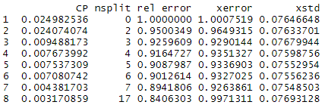
- (2 points) Apply both methods described in part (b). Recommend the number of splits to use in the pruned tree. Justify your recommendation.
Most candidates received partial credit on this task. Many candidates only applied one method correctly, failed to make a recommendation, or recommended a third method which could not be justified with the given information. Since the 1se rule results in x-error > 1, candidates were awarded full credit for selecting either the 0 split model or the 2 split model as the result of the 1se rule.
ANSWER:
The tree with 7 splits results in the lowest xerror in the table, 0.9263861. This is the tree that would be chosen using the minimum xerror approach.
Using the 1se rule, the lowest x-error is .9263861 + .07548503 > 1. However, it doesn’t make sense to prune a model such that zero splits are occurring, so the tree with 2 splits is chosen.
I recommend a decision tree with 7 spits and a complexity parameter of .004381703. This results in the minimal cross-validation error (see xerror column of the included CP table).

- (3 points) Recommend either to prune the overly complex tree with an optimally selected complexity parameter or to build a new tree with that same complexity parameter. Justify your recommendation.
Candidates struggled with this task overall. Most full credit responses chose to prune the complex tree and recognized that valuable splits after poor splits would be retained if the complex model was pruned. A common partial credit response was recommending pruning based solely on the fact that the complexity parameter was initially tuned based on pruning.
ANSWER:
I recommend pruning the overly complex tree with an optimally selected complexity parameter. By starting with an overly complex tree and then pruning back we retain more valuable splits that occur after less valuable splits. However, if we built a new tree with the same complexity parameter, those less valuable splits would not occur in the first place, and thus the more valuable splits would never be discovered.

Task 9 (10 points)
Your client has a goal to resolve missed pickups service calls to fewer than two days. Your boss wants you to build a model to evaluate this and suggests using AUC as a performance metric. (The data used is not in any of the supplied files.)
- (2 points) Explain the difference between accuracy and AUC in terms of overall model assessment.
Candidate performance was mixed on this task. Full credit responses provided correct definitions of both accuracy and AUC and recognized the key difference that accuracy is calculated at a single cutoff point while AUC is calculated across all possible cutoff points. Most candidate responses failed to provide a complete response.
ANSWER:
Accuracy is measured by the ratio of correct number of predictions to total number of predictions made. It doesn’t directly use the modeled probabilities, but rather the classifications based on a fixed cutoff point.
AUC measures the area under the ROC curve. It assesses the overall model performance by measuring how true positive rate (TPR) and false positive rate (FPR) trade off across a range of possible classification thresholds.
AUC measures performance across the full range of thresholds while accuracy measures performance only at the selected threshold.

Your assistant built a model and plotted the ROC curve below.
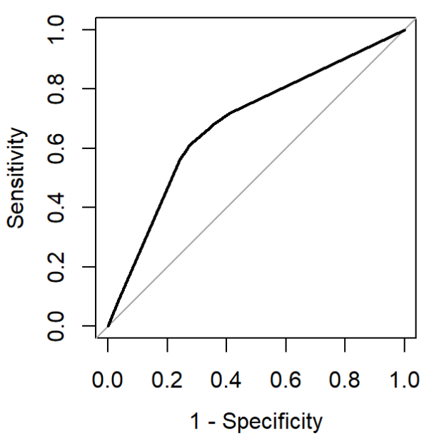

- (2 points) Explain why the ROC curve always goes through (0,0) and (1,1).

Candidate performance was mixed on this task. Common errors were not mentioning how points on the ROC curve vary by threshold and incorrectly defining Sensitivity or Specificity.
ANSWER:
The ROC curve plots Sensitivity on the y-axis and (1-Specificity) on the x-axis. The point (0,0) corresponds to a Sensitivity value of 0 and a Specificity value of 1, meaning 1-Specificity equals 0. Setting our classifier so that it never identifies a positive case will produce (0,0) because the true positive rate (Sensitivity) will be zero and with every case classified as negative the true negative rate will be 1. The (1,1) point is the opposite case where everything is classified as positive and the true positive rate (Sensitivity) rises to 1, while the true negative rate (Specificity) drops to 0.

Your boss suggests a boosted tree can increase model performance by reducing bias, however, setting hyperparameters is critical. You are asked to build a gradient boosting machine (GBM) tree model to assess the performance improvement.
The GBM tree model performance using the test data set is shown below.
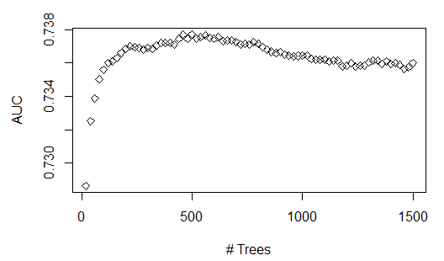
- (2 points) Explain why model performance improves at beginning then deteriorates as the number of trees increases.
Candidate performance was mixed on this task. Full credit responses identified that the pattern of performance on the test data results from overfitting and provided enough description of the mechanics of a GBM to explain how the overfitting occurred.

ANSWER:
A GBM iteratively builds trees fit to the residuals of prior trees. Depending on the hyperparameters, this model can produce a very complex model, which is susceptible to overfitting to patterns in the training data.
In this model, AUC on the testing data increases until the number of trees reaches about 500. However, as more trees are added beyond 500, AUC on the testing data starts to drop, which indicates the model is overfit to the training data.

- (2 points) Describe two hyperparameters you could adjust to improve model performance.
This task was straightforward, and candidates performed well overall. Any GBM hyperparameters could be chosen provided a correct justification.
ANSWER:
Early stopping: Early stopping criteria, such as improvement of the performance metrics in each subsequent tree, can stop training when it detects the improvement is marginal. This avoids overfitting.
Controlling learning rate: Learning rate controls the impact of subsequent trees to the overall model outcome. This reduces the extent to which a single tree is able to influence the model fitting process.

- (2 points) Explain the process of how to tune a hyperparameter.
Candidate performance was mixed on this task. Full credit responses described cross-validation and how it is used in the hyperparameter tuning process. Many candidates provided overly vague responses, often with no reference to cross-validation.
ANSWER:
Tuning a hyperparameter requires first varying the hyperparameter across a range of possible values and performing cross validation at each value. Performance is then determined based on a cross-validation performance metric, for example AUC, and the hyperparameter value with best performance based on this metric is selected.

Task 10 (6 points)

The client is interested in estimating the impact of various predictors on Time.to.resolution for two common complaints: “MISSED GARBAGE SERVICE DAY (GENERAL PICK-UP)” and “MISSING GARBAGE CART.” The client is interested in resolution time trends. Another concern is whether resolution times differ for certain areas within the city.

Run the given code and use the output to answer the following.

- (3 points) Interpret the coefficients for the time variables (year, quarter) for the two models (one for each complaint) using the summary() output. Also describe the trends of resolution times for each of the two complaints.
Candidates performed well on this task overall. Full credit responses interpreted coefficients in the context of the model form, interpreted the coefficient signs, and compared the coefficient trends across models.
ANSWER:
Model 1: Missed Garbage Service Day (General Pick-up)
Variable | Coefficient | Exp () | Decreasing by | Interpretation
Year | -0.82764 | 0.43709 | 0.56292 (56%) | Each year, missed general pickup is expected to decrease by 56%, all other variables held equal
Q2 | -0.15566 | 0.85585 | 0.14415 (14%) | Q2 is expected to have 14% fewer missed pickups than Q1, all other variables held equal
Q3 | -0.74749 | 0.47355 | 0.52645 (53%) | Q3 is expected to have 53% fewer missed garbage carts than Q1, all other variables held equal
Q4 | -0.83595 | 0.43346 | 0.56654 (57%) | Q4 is expected to have 57% fewer missed garbage carts than Q1, all other variables held equal

Model 2: Missing Garbage Cart
Variable | Coefficient | Exp () | Change | Interpretation
Year | -0.17612 | 0.83852 | 0.16148 (-16%) | Each year, missing garbage carts is expected to decrease by 16%, all other variables held equal
Q2 | 0.25359 | 1.28865 | 0.28865 (+29%) | Q2 is expected to have 29% more missed garbage carts than Q1, all other variables held equal
Q3 | 0.34085 | 1.40615 | 0.40615 (+41%) | Q3 is expected to have 41% more missed garbage carts than Q1, all other variables held equal
Q4 | 0.38793 | 1.47393 | 0.47393 (+47%) | Q4 is expected to have 48% more missed garbage carts than Q1, all other variables held equal

The year coefficients are negative for both complaint TYPEs. This implies that response times are reducing over time, from year to year. For the “missed general pickup” TYPE, the time.to.resolution improves as you move into later quarters in a year. For the “missing garbage cart” we see the opposite trend with time.to.resolution increasing as you move into later quarters in a year.

- (3 points) Using the summary and drop1 output, compare and contrast the significance of the area variables in the two models. Quantify significant differences in resolution times.
Candidates performed well on this task overall. Full credit responses discussed the output of the summary and drop1 functions, provided justification for why variables were significant or not, and quantified significant differences in response time over the baseline.
ANSWER:
Based on summary output:
- In model 1, the area variable is significant with a p-value of 3.02e-08. The coefficient for areaW = 0.20493 means that time.to.resolution for areaW is higher than the reference level, areaD, by exp(0.20493) – 1 = 22.74%.
- In model 2, none of the area categories are significant with all p-values greater than 0.5.
Based on drop1 output:
- In model 1, dropping the area variable gives a higher AIC, suggesting that the area variable should not be dropped.
- In model 2, dropping the area variable gives a lower AIC, suggesting that the area variable should be dropped.

Task 11 (8 points)
You are investigating data on calls for damaged carts using Time.to.resolution as the target variable. This dataset includes an additional variable “Service.Request.Id.” This variable is set to 1 for the first request and incremented by one at each subsequent request. Your assistant has removed this variable, arguing that it is not of any value for predicting Time.to.resolution, given that is merely a counter that reflects the row of the observation. (The data used is not in any of the supplied files.)
- (2 points) Critique the assistant’s recommendation.
Most candidates received partial credit on this task. Full credit responses stated an opinion of the assistant’s recommendation and justified it with a thoughtful discussion of how the variable could be used in modeling.
ANSWER:
I disagree with the assistant’s recommendation as stated. This variable should not be removed without further investigation. Changes in the ID values over time could identify useful information such as changes in systems or changes in data collection approaches.
Before removing or eliminating a predictor you should at least check for any correlation between it and the target or other predictor variables. It is best to check for patterns or other characteristics that may be of use in feature generation.
You may need to consider multicollinearity with other date and time variables. Multicollinearity could cause issues with many model fitting algorithms.

- (1 point) Define an interaction effect.
Candidates generally performed well on this recall question.
ANSWER:
An interaction effect is when the target variable has a relationship with a combination of input variables in addition to potentially having a relationship with those variables on their own.

Many service calls for damaged carts have resolution times over 60 days. You have been asked to look at these in more detail. Your assistant has built an initial model to predict if a damaged cart call will take more than 60 days to service. The predictive variables used are: year, month, DEPARTMENT, LATITUDE, LONGITUDE. Consider interactions among the predictor variables.
- (2 points) Propose two variables to make an interaction term that may improve model accuracy. Justify your proposal.
Candidates performed well on this task overall. The most common full credit responses proposed an interaction between department and year. However, some candidates received full credit for proposing an interaction between LATITUDE and LONGITUDE.

ANSWER:
An interaction term between year and DEPARTMENT could improve the model fit. The various departments may trend differently over time and this nuance can be captured through a time variable and department interaction.

You continue working on a model to predict if a call for a damaged cart will have resolution times over 60 days. A new indicator variable “Over60” has been created to identify records that have a resolution time greater than 60 days.
Your assistant is testing different link functions for predicting Over60. Your assistant notes that some model predictors are highly statistically significant with certain link functions but not with others.
- (3 points) Explain how changing the link function in the GLM impacts the model fitting and how this can impact predictor significance.
Candidates struggled with this task overall. Full credit responses defined what a link function is, explained how link function impacts error terms, which ultimately impacts model fitting and whether predictor variables are statistically significant.
ANSWER:
The link function specifies a functional relationship between the linear predictor and the mean of the distribution of the outcome conditional on the predictor variables. Different link functions have different shapes and can therefore fit to different nonlinear relationships between the predictors and the target variable. For example: if predictor variables have very linear relationships to the mean, a link function that preserves that linearity (like the identity link function g(u) = u) should provide a better model fit than a link function that creates a more nonlinear, curved relationship to the mean.
When the link function matches the relationship of a predictor variable, the mean of the outcome distribution (the prediction) will generally be closer to the actual values for the target variable, resulting in smaller residuals and more significant p-values.

Task 12 (7 points)
Your assistant mentions that using latitude and longitude for each service call would allow the mapping of each call to a zip code. By using publicly available census information, the data by zip code could be combined with information such as average age, predominant race, and average household income.
- (1 point) Define proxy variable.
Candidate performance was mixed on this task. Responses that demonstrated understanding that proxy variables provide information about a variable that was not directly measured received full credit. A common response that received no credit was defining a proxy variable as a variable that contains sensitive information.
ANSWER:
Proxy variables are variables that are used in place of other information, usually because the desired information is either impossible or impractical to measure. For a variable to be a good proxy it must have a close relationship with the variable of interest.

- (3 points) Evaluate your assistant’s recommendation for any potential legal or ethical concerns including whether proxy variables should be used in this project.
Candidate performance was mixed on this task. Full credit responses Included a description of legal/ethical issues, a discussion of whether there is problematic information in the data that should be addressed, and additional justification based on the context of the business problem.
ANSWER:
Data such as race, age, and income are generally considered sensitive information. Some jurisdictions have legal constraints on the use of sensitive information. Before proceeding there should be consideration of any applicable law. There are no clear rules for what ethical use of data is. Good professional judgement must be used to ensure that inappropriate discrimination is not occurring within the model or the project. Public perception should also be considered. The politician or the city could suffer bad press if there is a belief that the project inappropriately discriminates.
Since LATITUDE and LONGITUDE were used to lookup race, age, and income, including them in a model is clearly creating proxy variables for this sensitive information. Simply not using the census data may not be completely safe for eliminating potential inappropriate discrimination in the model or the project.
However, given the project goal of identifying inequities, using the census data may be a valid way to test that the model and project decisions are fair or even improve equity among demographic groups.

Your assistant states that the values for latitude and longitude are too granular and proposes that the data be grouped for modeling. Your assistant groups the data by splitting the ranges of both latitude and longitude into 20 equally spaced bins and creating factor variables Latitude_Binned and Longitude_Binned. For each combination of Department, year, month, Latitude_Binned and Longitude_Binned the average Time.to.resolution and the total count is stored in variables Ave.Time.to.resolution and call_count.
Using this grouped data, your assistant then models the Ave.Time.to.resolution using two Poisson regression models, Poisson.1 and Poisson.2. The code for these models is provided.
- (3 points) Assess the differences between the two models, including fitted parameters, coefficient estimates, goodness of fit.
Candidates performed reasonably well on this task overall. Common reasons for partial credit were not correctly identifying the difference between the specifications of the two models and not comparing the goodness of fit of each model.
ANSWER:
Poisson.1 gives equal weight to each observation while Poisson.2 weights each observation by number of calls. This means observations with a small numbers of service calls contribute as much in fitting Poisson.1 as observations with a high number of calls.
Observations with a small number of calls generally have more variation since the target variable is averaged across fewer calls. Poisson.1 gives these observations relatively more weight than Poisson.2, leading to larger deviance. This is why Poisson.1 has a worse fit (AIC = 136.07) than Poisson.2 (AIC = 98.686).
Poisson.2 generally has coefficients that are closer to 0 than Poisson.1. Although both models find the intercept, DEPARTMENTSANITATION, and year to be significant, this leads to Poisson.1 having more significant p-values.

Source: City of Baton Rouge Parish of East Baton Rouge.

